Major Web Project

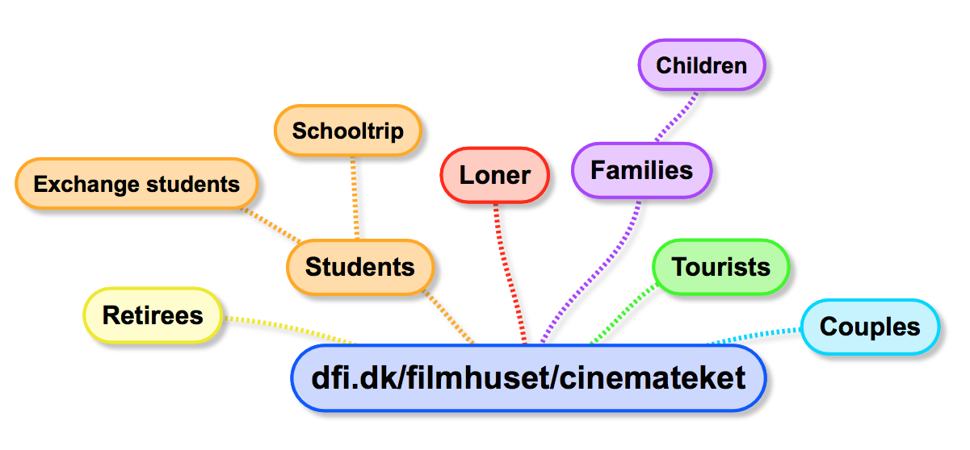Mandatory Assignment: Developing ideas for website:   
 [http://www.dfi.dk/Filmhuset/Cinemateket/Billetter-og-program/Serie.aspx?serieID=11464/](http://www.dfi.dk/filmhuset/Cinemateket/danish.aspx)

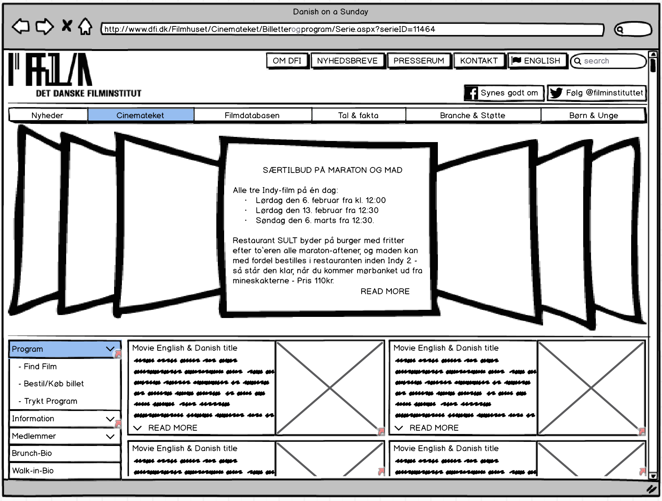

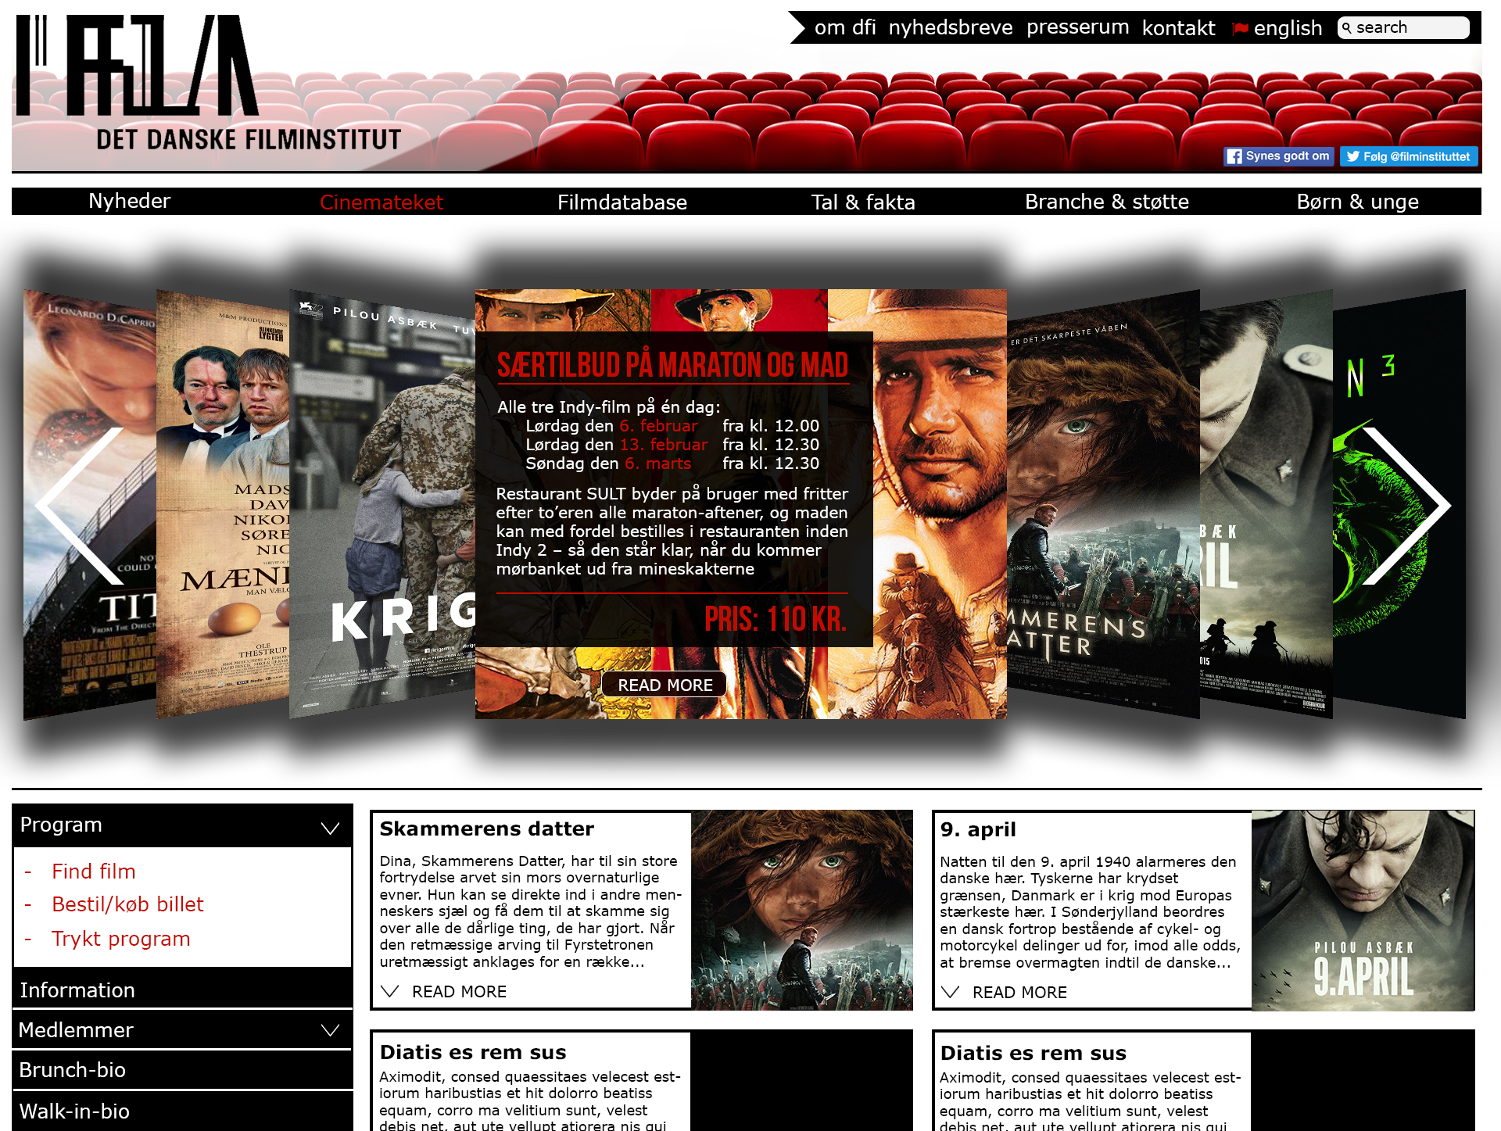

By: Asger Balle Pedersen

Index

Part 1 - Use Design Thinking to Understand User Needs 3

Know your Users - User Personas 3

Brainstorm of personas 3

Description of the two personas 4

Describe the Scenes - Activities, Environments, Interactions, Objects and Users 4

Create a Point-of-View Statement 5

Create a “How might we…” 5

Part 2 - Sketch and storyboard wireframes to visually layout your site´s content, structure and interaction 6

Wireframe for the Desktop Version 6

Mock-up: Main 6

Mock-up: Sub-Movie 7

Mock-up: Sub-movie-awards 8

Mock-up: Sub-Movie-Serie 9

Mock-up: Sub-info 10

Mock-up: Sub-info-nav 11

Wireframe for the Mobile Version 12

Mock-up: Main 12

Mock-up: Sub-movie 13

Mock-up: Sub-Info 14

How might we… 15

Part 3 - Communicate the Visual Design of your Site 16

Web version - Main 16

Mobile Version - Main 17

Web version - Sub-movie 18

Mobile version Sub-movie 19

Web version - Sub-info 20

Mobile version - Sub-info 21

# Part 1 - Use Design Thinking to Understand User Needs

## Know your Users - User Personas

To identify the user personas we gather all personas we can think of related to the website in a brainstorm. From the brainstorm we will research the different areas of two personas to determine their behaviour, motivation, social circles, etc.

### Brainstorm of personas



* Students are trying to get the most out of their money, so both quality and quantity is relevant. The students are often more mobile and might have many goals for going to the movie; Social-small talk-starter afterwards, clearing the mind of the everyday workload, social group-bonding etc.
* Retirees would like a full experience; paying for better seats, ordering seat in advance (close to toilet perhaps), eating nearby in a restaurant (often more expensive and appealing ones).
* The Loner is one of the lowest segments attending a movie, these are much targeted and know the background of the movie (might have read the book, seen older version, etc.).
* Families are often 2-4 people in total and are influenced by the kid(s) behaviours and what they want or have seen on TV. The parent exploits this to be socially active with other parents attending the same movie, perhaps even call a fellow parent to bring them. Otherwise, a single parent could be on the lookout for another single parent.
* Tourists are in town looking for the real Danish culture in a hurry. It should be easily accessible without a lot of work ahead understanding the theme or understanding the universe.
* Couples want a movie where they do not need to be fully focused all the way (due to the sharing of popcorn, etc.) The men would like a resume, a description of the universe around the movie, some of the director’s opinions and perhaps a critic’s point of view, all to impress the other part if there is a moment of confusion or silence before/after the movie.

### Description of the two personas

We have chosen two personas characteristics from the brainstorm: The Exchange Student and A Couple having 6th month anniversary.

The Exchange Student:   
Sarah is 25, just started her M.Sc. in Copenhagen University in Medicine and has a part time job as a secretary to keep up with the monthly expenses. She wants to learn more about Denmark, but the studies make it difficult to rip a whole day from the calendar.

A Couple having 6th month anniversary

Kevin and Kate live together. Kate just moved from Germany and finds everything new. She tries hard to get a job but find the Danish system confusing. Kevin works long hours at an office. He sees Kate’s struggling and is planning to give her roses, dinner and a movie.

## Describe the Scenes - Activities, Environments, Interactions, Objects and Users

In the following section we will identify, analyse and describe Sarah´s behaviour before, during and after the movie-going experience in the cinema. It all starts with Sarah overhearing her colleagues on the job talking about a new movie called “Skammerens Datter”. She turns to them, asks about the movie and apparently it is a Danish national book, that almost everyone has been forced to read during childhood in elementary school.

Activity:  
Sarah looks up the movie at the webpage to see date, time and price of the movie as well as the movie theatre’s location in Copenhagen. She also needs to look up the movie “Skammerens Datter” on the Internet, to figure out more about it. It is her intension to invite a friend along, but she needs to know if the movie is in her taste and if it is any good.

Environment:  
Sarah is back home in her apartment with her laptop in the sofa. She is enjoying a hot cup of coffee and listening to the band AC/DC playing “Thunderstruck” originating from the sound blaster system. Sarah’s phone is next to her on the table just to the left of the coffee cup.

Interactions:  
From the interaction earlier with the colleagues they told her about the book version more or less from their school time, but they were not very specific on details. Sarah is searching the webpage to see if and when the movie is shown. She is also especially interested in knowing about review and special remarks the movie has been given, before she can invite her friend along.

Objects:  
Sarah, sofa, laptop, table, coffee cup, Internet, web ticket-sale

Users:  
Sarah is relaxing and easily finds the date and time of the movie and she really likes the small English appetiser. However, she gets a bit frustrated as she begins to search the Internet for the critic’s reviews, having to ensure it is not the book or another movie version that she is reading about.

## Create a Point-of-View Statement

Point-of-view statement frames the problem at hand from the user’s point-of-view.

User:

We are designing the webpage for students, more specifically exchange students with the emotional needs for exploring the culture and what their new surroundings can offer.

Need: An exchange student needs to know;

* That the movie is the right one concerning both the Danish and English title translation.
* Reviews and awards the movie has received in order to choose the right one.
* The location of the cinema in Copenhagen.
* The choice of public or private transportation through town (considering maintenance)
* Determine clothes to wear pending on the weather.
* A place to eat before or after the movie pending on the time it is playing.
* A place to go get a cocktail or beer.

Insight:

The most surprising fact about the user is the amount of planning, before actually ordering the tickets to the movie. From a business point of view the fear of losing the costumer to another competing website or company is huge during this planning period, which only grows as user needs to look elsewhere on the Internet to find reviews, navigation, restaurant, bar, etc. To improve the chances of the user buying the tickets, the webpage could provide and display rewards and reviews from critics that the movie has received.

## Create a “How might we…”

Amplify the good:

How might we help Sarah amplify the good in sharing Danish culture through movies to foreigners?

Diminish the bad:

How might we diminish the discomfort for Sarah with the amount of planning before going to the movie?

Reframe the bad into good:

How might we help Sarah collect info and plan her Sunday with her friend?

# Part 2 - Sketch and storyboard wireframes to visually layout your site´s content, structure and interaction

In the following section, we describe the functions, structure and content in order to visualise the layout of our website. We have determined the resolutions of the webpage based on the W3C stats[1] to be 768 x 1024 px, due to fact that almost 40% of the users have this. The “Danish on a Sunday” website will still be a part of dfi.dk and therefore it keeps the original header, head-banner and top-menu from the primary website. In order to navigate within the “Danish on a Sunday” website a navigation bar to the left is provided. The Wireframes for the desktop version consist of 6 mock-ups, but only the three Mock-ups: “Main”, “Sub-movie”, “Sub-info” will be used further on in the assignment.

## Wireframe for the Desktop Version

### Mock-up: Main



Mockup:

Sub-info

Mockup:

Sub-Movie

This wireframe provides a greater overview of the content of the sites and allows the user to be inspired from the cover-flow with upcoming events, special offers etc. On the left, below the cover-flow, the user can navigate in the navigation-bar to find and order movie, collect information and enter the member’s area. On the right of the navigation-bar, all current movies playing (views) are shown with both the Danish and English title along with a short appetiser.   
*\* The user clicks on a movie-view and is linked to Sub-Movie*

### Mock-up: Sub-Movie

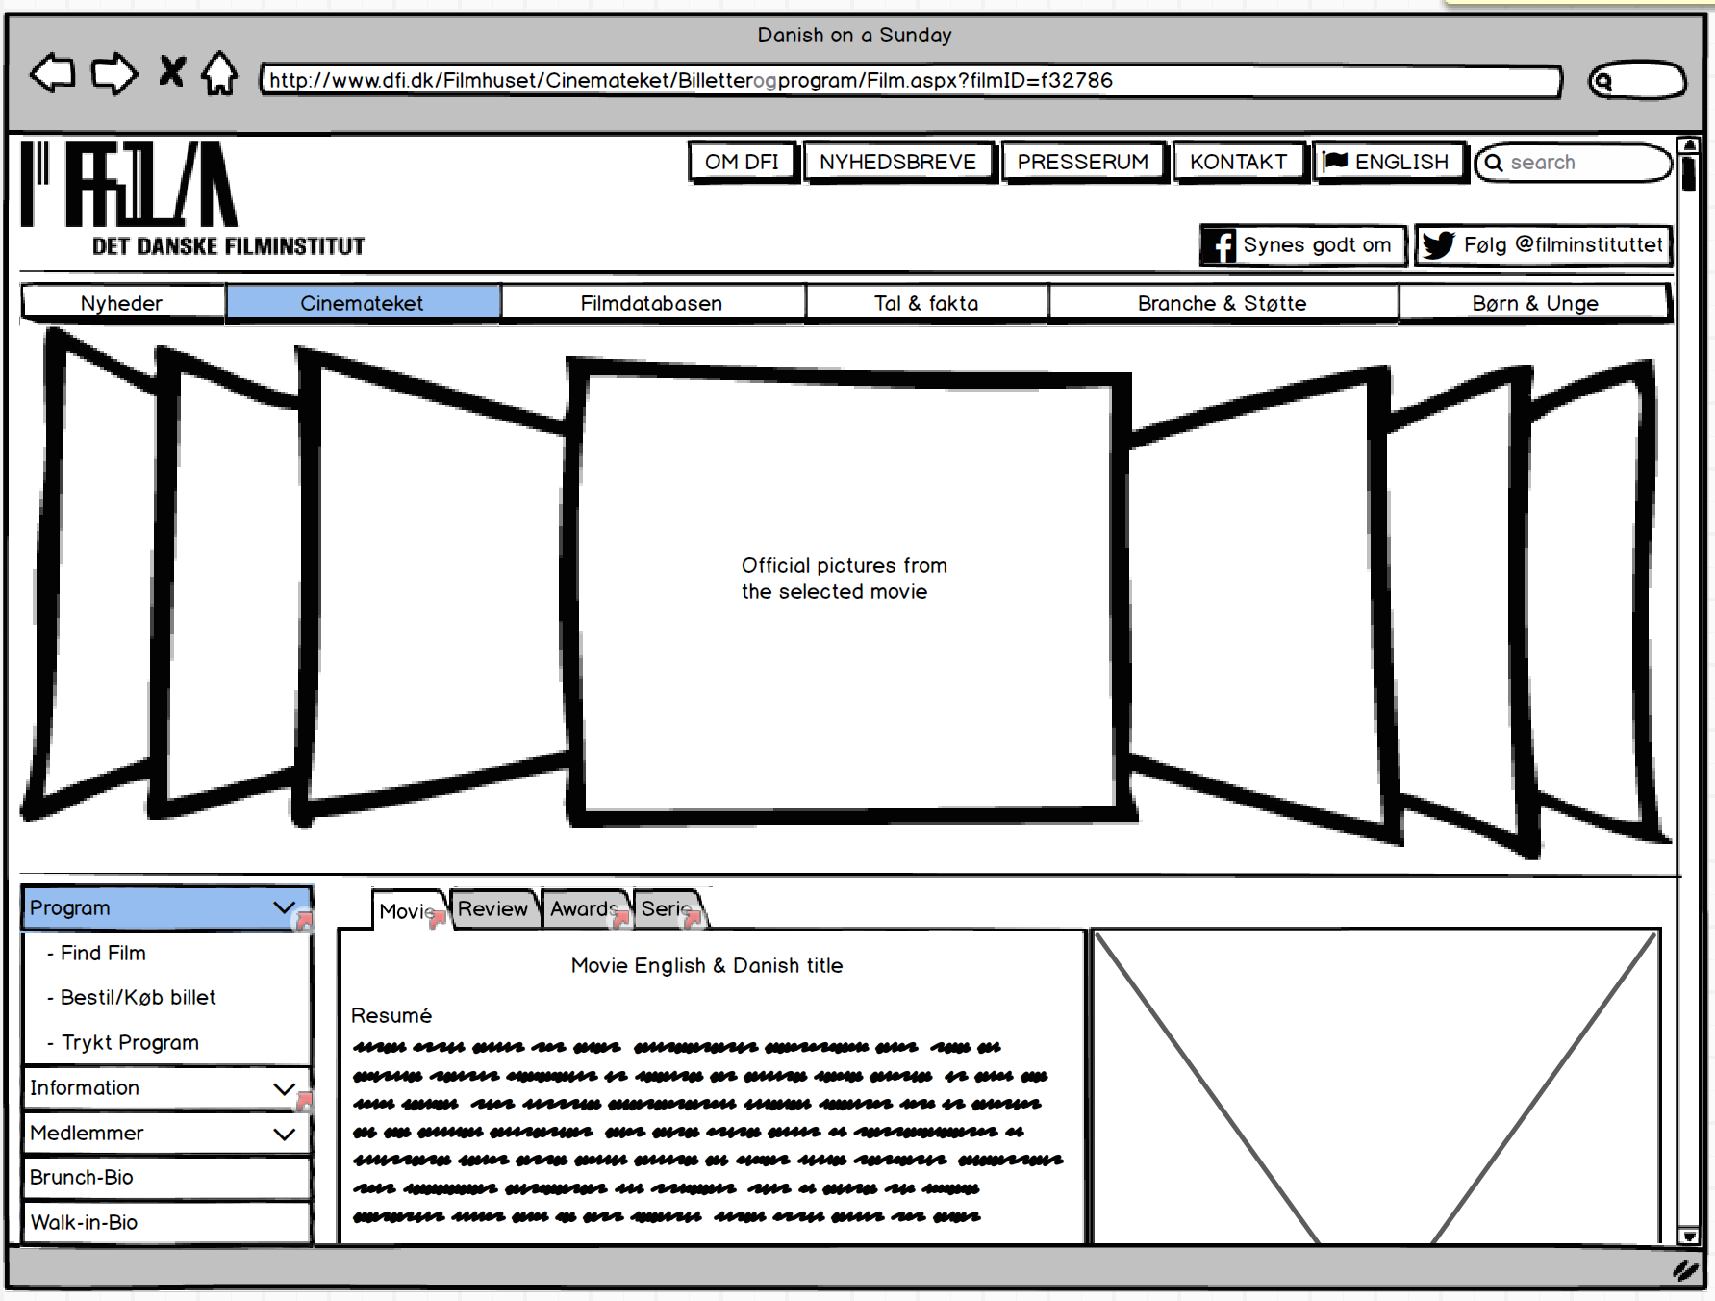

Mockup:

Sub-info

Mockup:

Main

Mockup:

Sub-Movie-Serie

Mockup:

Sub-Movie-Awards

The wireframe alters the content of the cover-flow to only display this movies official pictures and posters ( also special offer, if it is for this movie). The area with the 4 views, from mock-up: main, is switch with one big view displaying the Titles, Resume, Official Movie Poster(right) and below this are price, time, date, length etc. displayed. In the top 4 tabs are revealed: “Movie, Review, Awards and Serie”

*\* The user clicks on the tab “Awards” and is linked to Sub-Movie-Awards*

### Mock-up: Sub-movie-awards

Mockup:

Sub-Movie

Mockup:

Sub-Movie-Serie

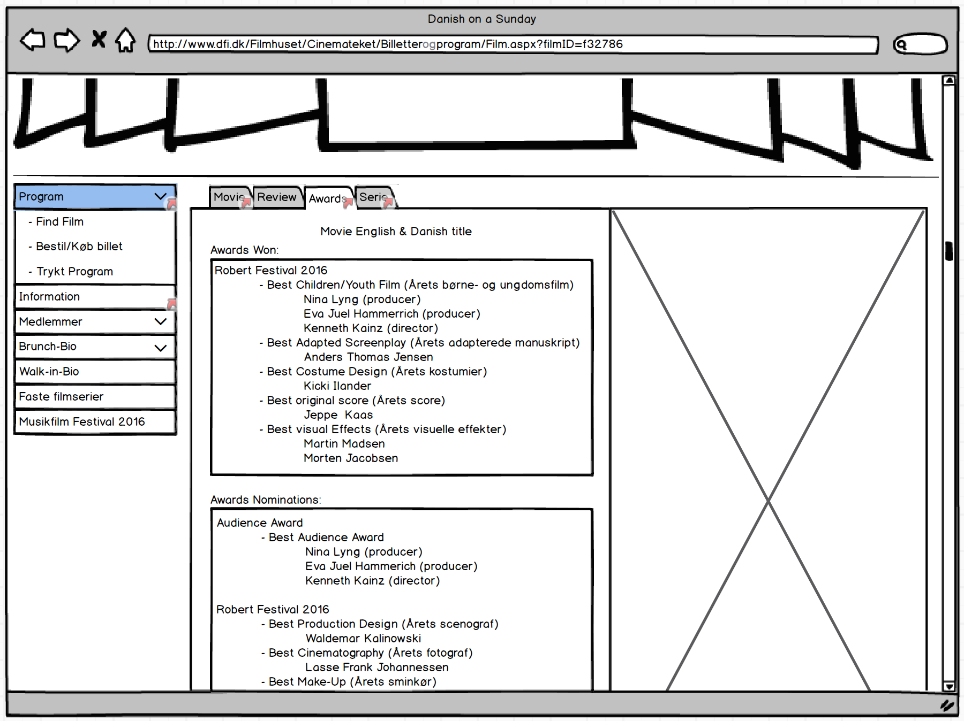

Mockup:

Main

Mockup:

Sub-info

The cover-flow stays the same only display this movies official pictures and posters (also special offer, if it is for this movie). The big view now displaying the Titles, Awards won and nominations in a grid and still with the official movie poster to the right.

*\* The user clicks on the tab “Serie” and is linked to Sub-Movie-Serie*

### Mock-up: Sub-Movie-Serie

Mockup:

Sub-Movie-Awards

Mockup:

Sub-Movie

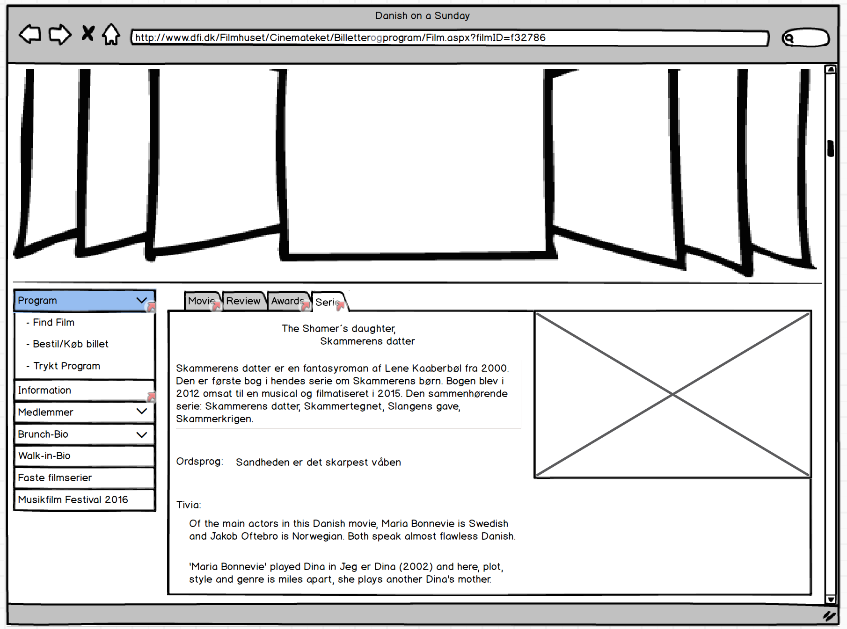

Mockup:

Main

Mockup:

Sub-info

The cover-flow stays the same only displaying this movies official pictures and posters (including special offer, if possible is for this movie). The big view now displays the titles, a description of the universe and small amount of facts associated with the film. It is here the user clearly should know that the film is based on a Danish national book and the first in a series of 4. The picture to the right could be the author with all 4 books together.

*\* The user clicks on the navigation-bar “Information” and is linked to Sub-info*

### Mock-up: Sub-info

Mockup:

Sub-info-nav

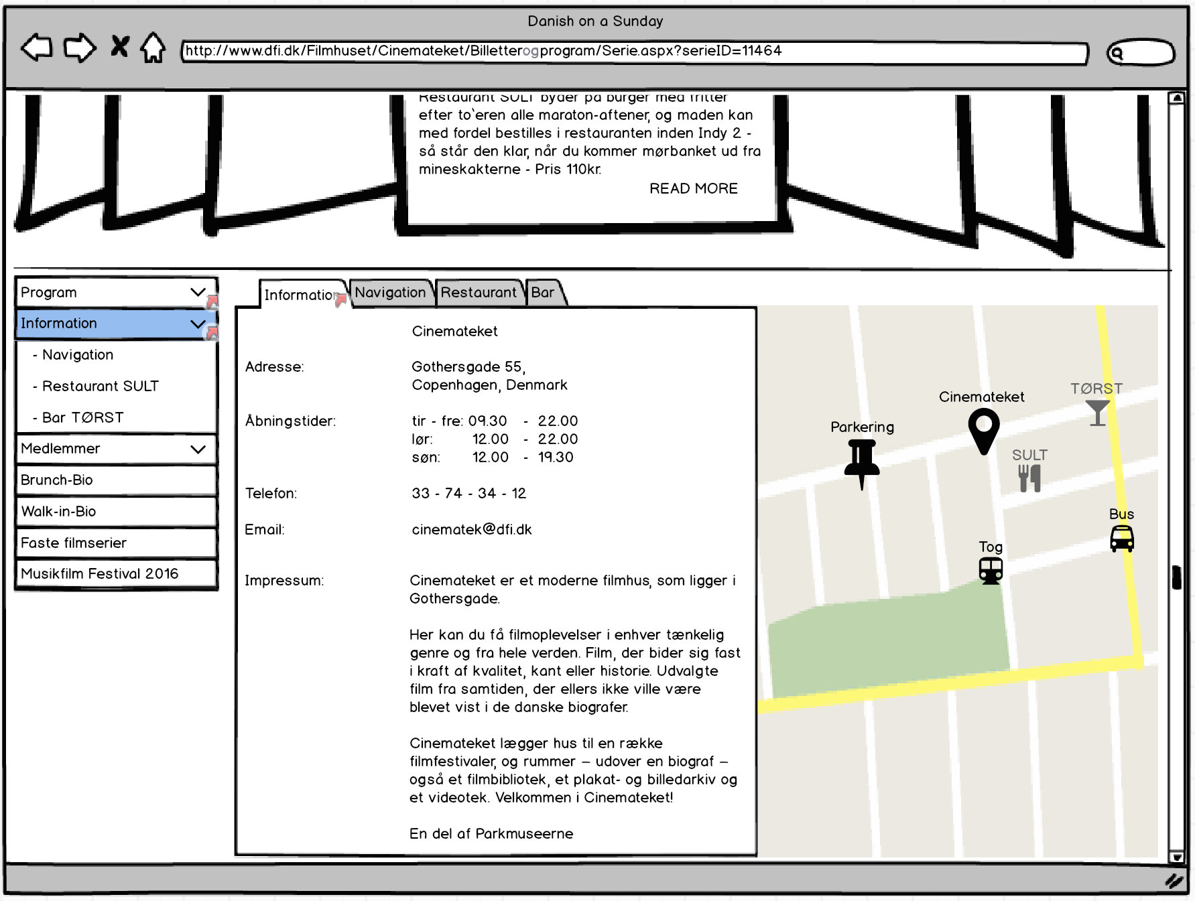

Mockup:

Sub-info

Mockup:

Main

The wireframe alters the content of the cover-flow back to it original inspiring state with all upcoming events, special offers, etc. The navigation-bar folds out with new options and a new big view appears with information. In the top of the big view 4 tabs are revealed: “Information, Navigation, Restaurant and Bar”. The view itself contains a list of contact information both address, telephone and the weekly opening/closing hours. The map to the right provides the location of the Cinemateket, Parking area, Train station, Bus stop, the Restaurant SULT and the bar TØRST. This should ease the planning by locating the different transportation options and how to go around.

*\* The user clicks on the tab “navigation” and is linked to Sub-info-nav.*

### Mock-up: Sub-info-nav

Mockup:

Sub-info

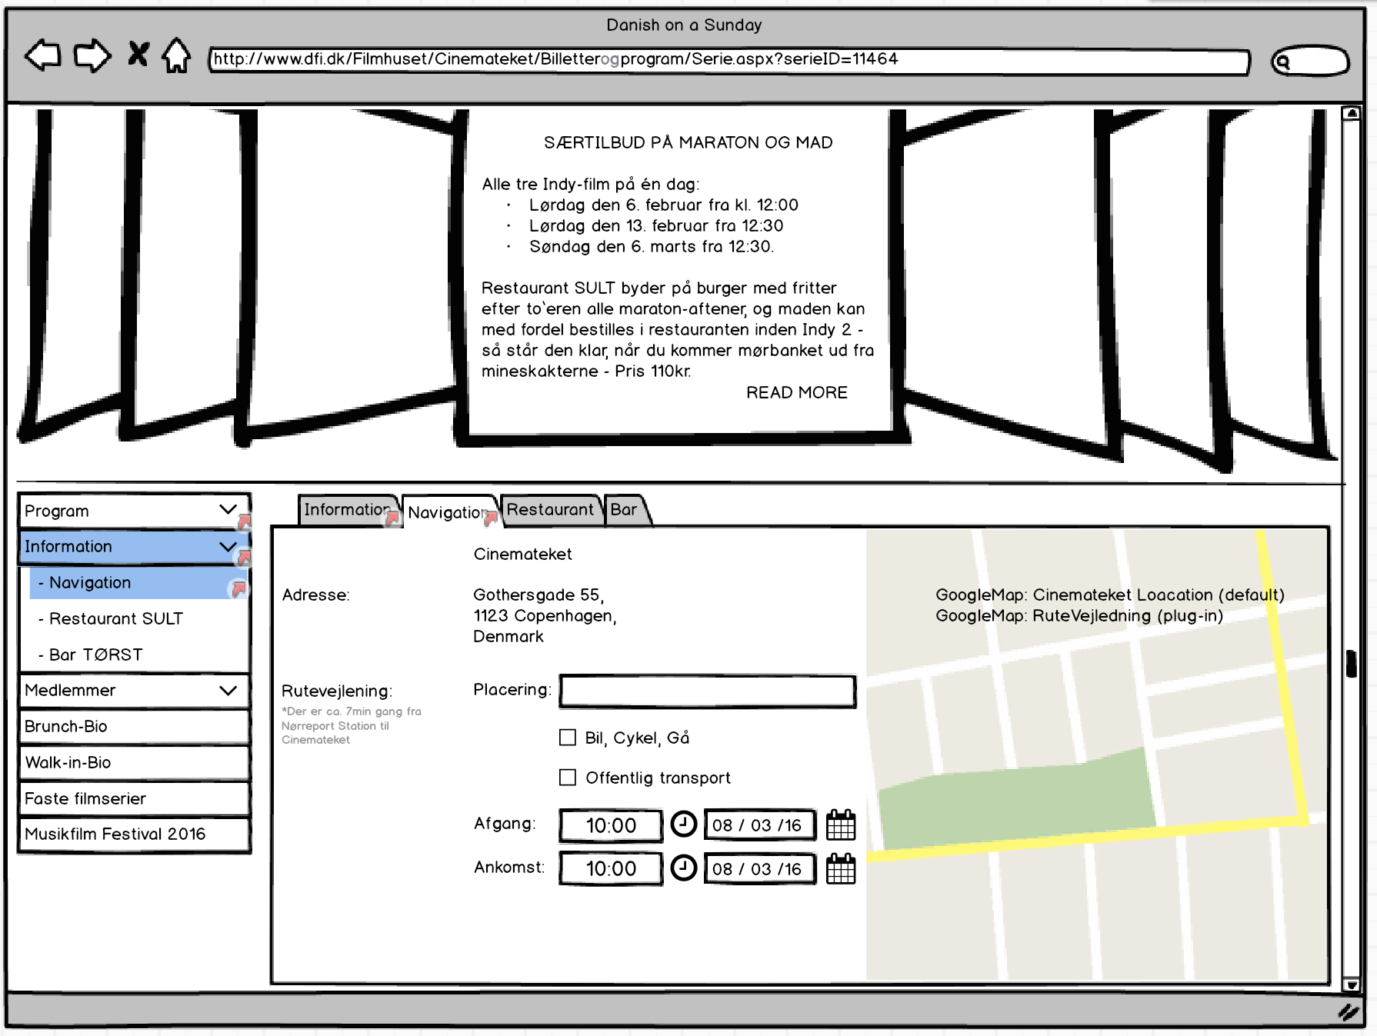

Mockup:

Main

Mockup:

Sub-info

The cover-flow stays the same with its original inspiring state. The big view changes to a route planner still with a big map to the right. In this view, the user can type in his/her location and pending on choice of public/private transportation. It helps the user plan the trip all the way to Cinemateket. The route planner takes into account that the user should not arrive later than the arrival time provided by the user. It should also be able to display scheduled maintenance on public transportation and work around that.

## Wireframe for the Mobile Version

### Mock-up: Main

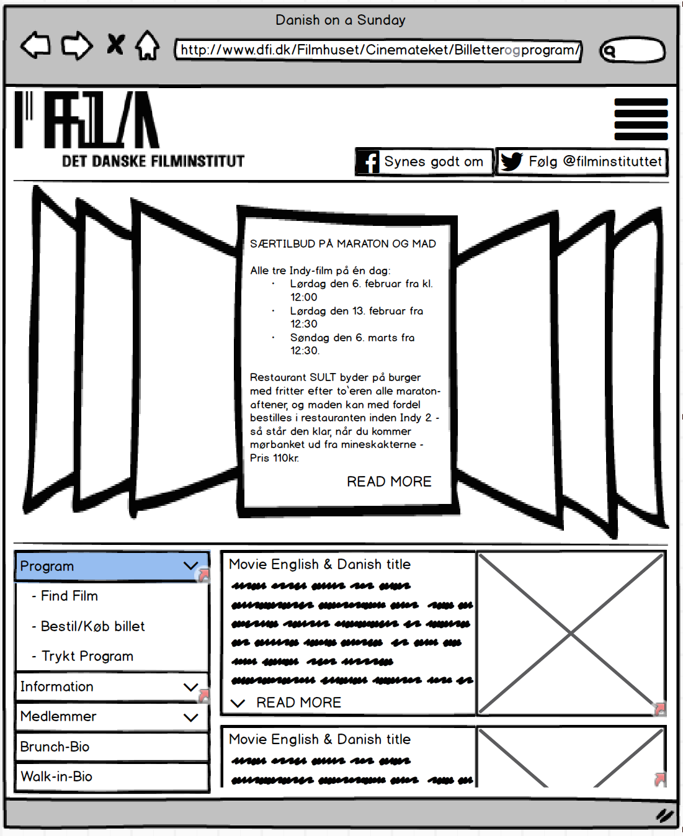

Mockup:

Sub-info

Mockup:

Sub-movie

The mobile wireframe keeps the header from the website, but compresses the menu into the icon in upper right corner. The cover-flow and navigation are untouched, but the 4 views from desktop version has been cut 50%. This keeps the objects big enough for the user “on the go” to easily click them.

### Mock-up: Sub-movie

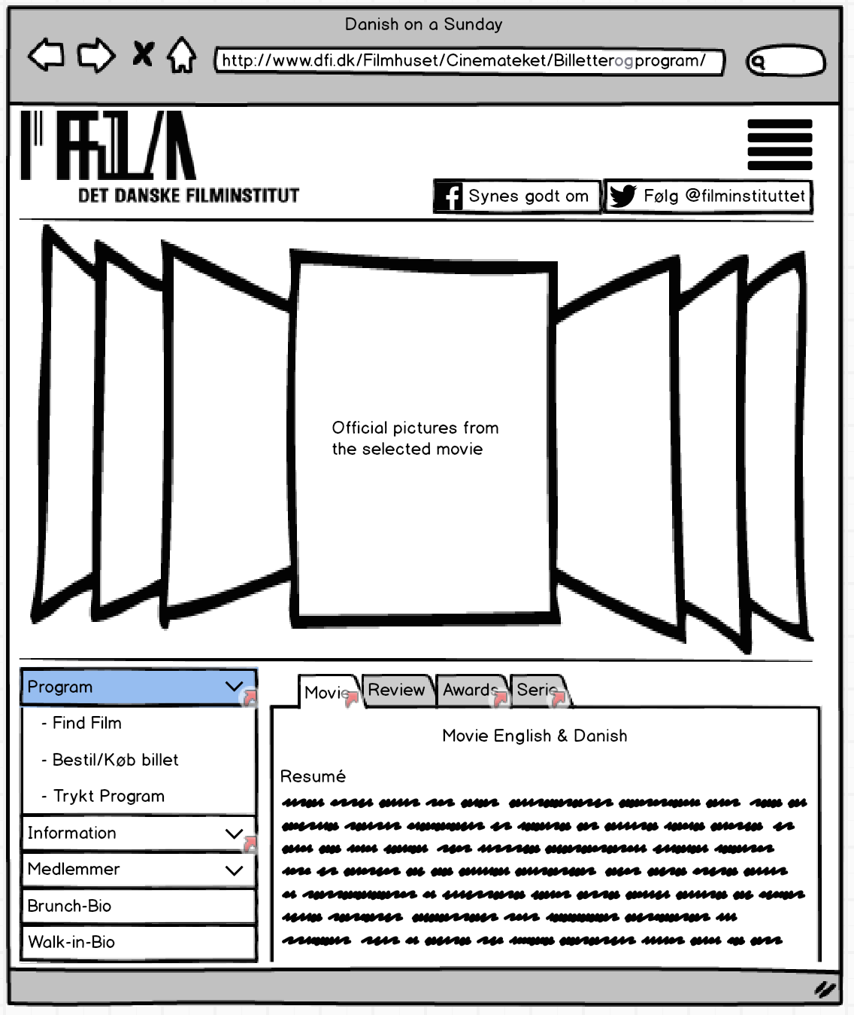

Mockup:

Main

Mockup:

Sub-info

The only difference in this wireframe, form the desktop version, is that the picture to the right has been put under the navigation-bar in a smaller size. This keeps the text size readable and the tabs clickable without much effort.

### Mock-up: Sub-Info

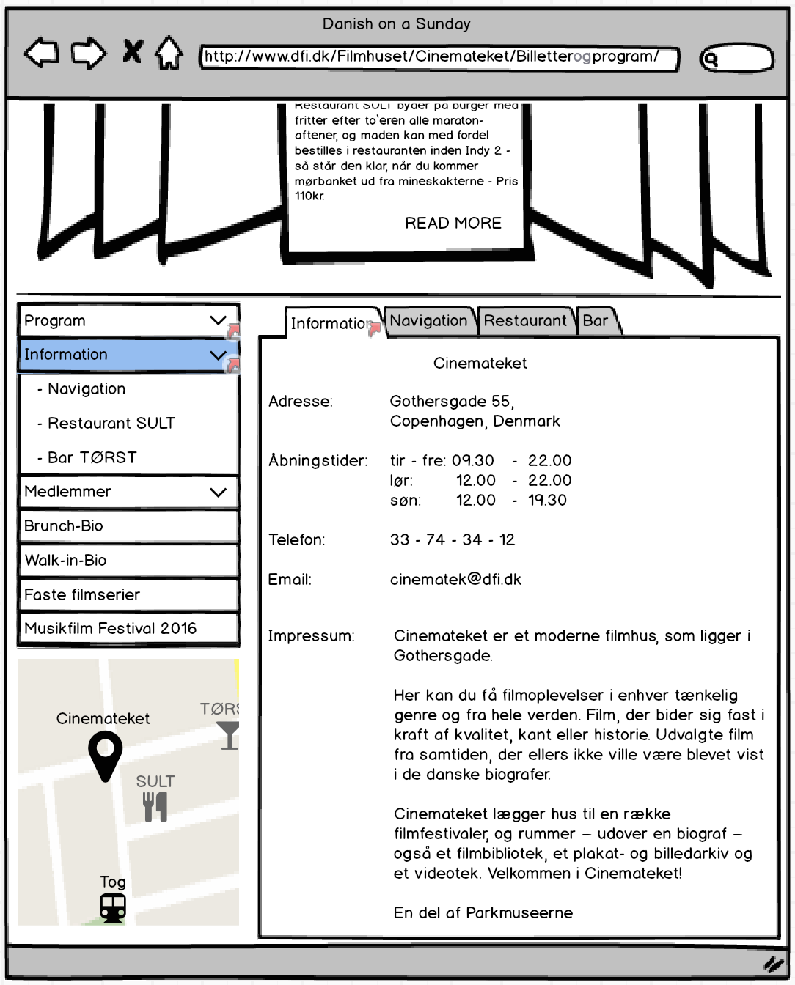

Mockup:

Main

Mockup:

Sub-info

This wireframe shows how the picture/map from the right in the desktop version replaces under the navigation-bar. This same behaviour is found in Sub-Movie, Sub-Movie-Awards, Sub-Movie-Serie, Sub-info-nav.

## How might we…

Amplify the good:

How might we help Sarah amplify the good in sharing Danish culture through movies to foreigners?

- This could be done through the integration of Facebook and tweeter announcement. Sarah may have the opportunity of using a special offer; see the next movie with the same friend and save 50%.

Diminish the bad:

How might we diminish the discomfort for Sarah with the amount of planning before going to the movie?

The amount of planning, reading reviews and finding information on the Internet from Sarah’s point-of-view is reduced due to new tabs in Sub-movie: review, awards, and series along with the Sub-info providing local guidance.

Reframe the bad into good:

How might we help Sarah collect info and plan her Sunday with her friend?

Sarah has the option to write the desired starting point for both her and her friend, telling which train/bus or road to take (should become print-mail-able).

Sarah can easier find information, not only about the movie itself, but also the universe, comments etc. all in favour of Sarah picking just the right movie to see with her friend. Special offers can also reframe the bad into something good by being able to reserve a table at SULT 1, 5 hour before the movie starts ensuring a good experience before and during the movie, just knowing that everything has been taken care of.

# Part 3 - Communicate the Visual Design of your Site

The following photo-shop pictures shows the visual design for the website both for the web version and the corresponding mobile version.

## Macintosh HD:Users:Asger:Dropbox:Asger Privat:ITU:2. Semester:Frameworks and Architectures for the web:Mandatory assignment 1:Photoshop:Web:Asger index.pngWeb version - Main

## Macintosh HD:Users:Asger:Dropbox:Asger Privat:ITU:2. Semester:Frameworks and Architectures for the web:Mandatory assignment 1:Photoshop:Mobile:Asger mobile main.pngMobile Version - Main

## Web version - Sub-movie

## Macintosh HD:Users:Asger:Dropbox:Asger Privat:ITU:2. Semester:Frameworks and Architectures for the web:Mandatory assignment 1:Photoshop:Web:Asger skammerens datter.png

## Mobile version Sub-movie

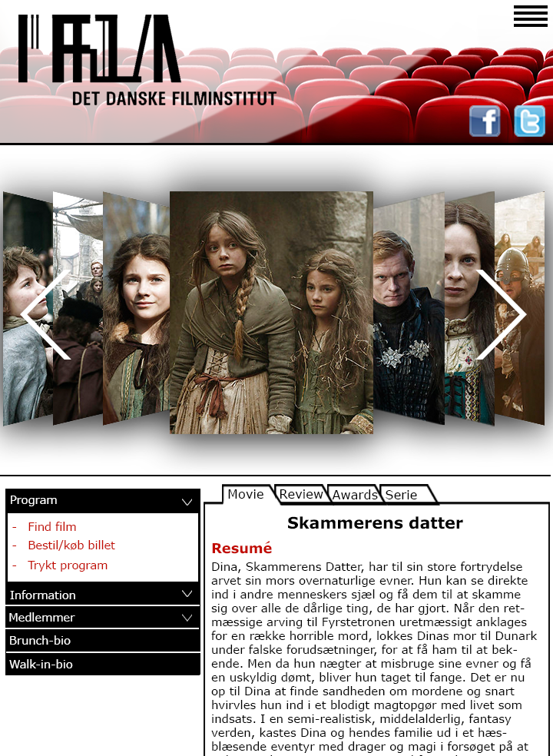

## Web version - Sub-info

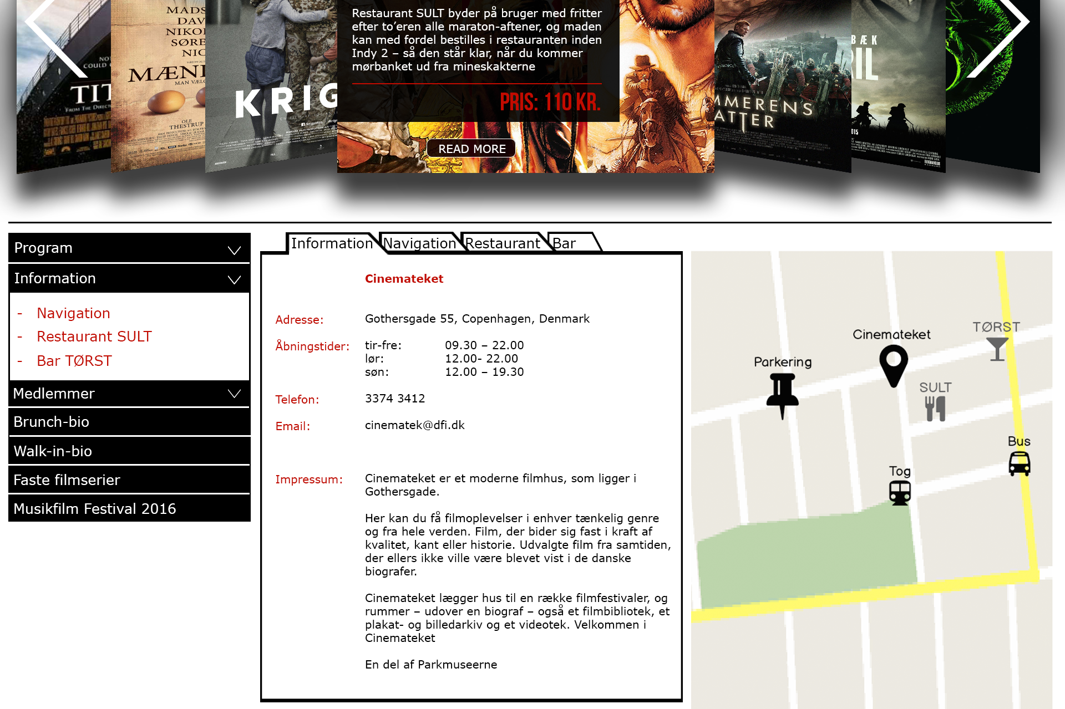

## Mobile version - Sub-info

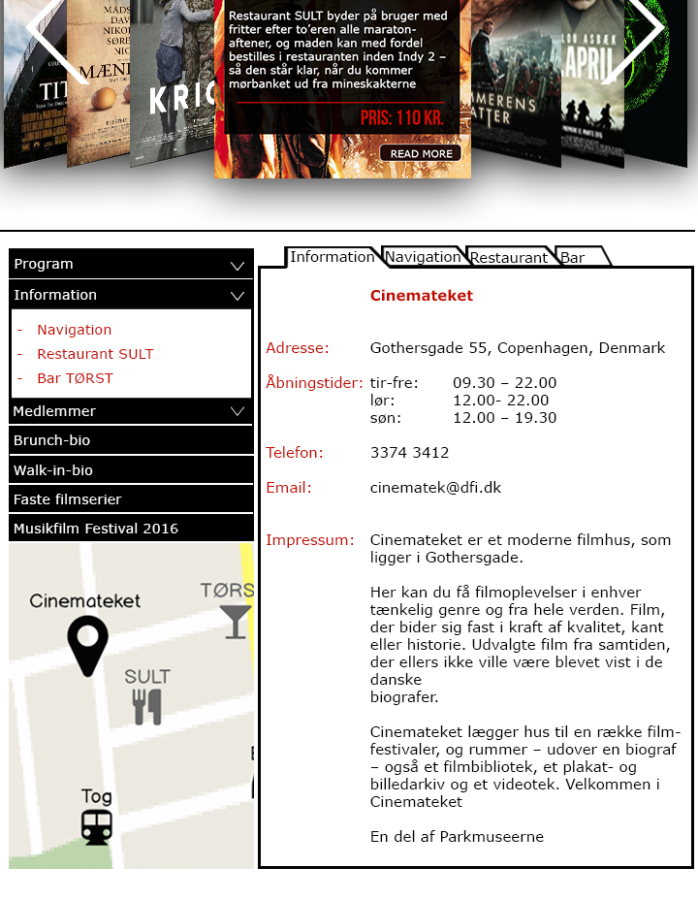

1. <http://www.websitedimensions.com>